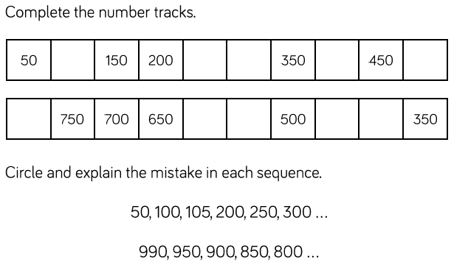

Circle and explain the mistake in each sequence.

50, 100, 105, 200, 250, 300 …

What is the pattern? ___________________________

Explain the mistake ____________________________________________

____________________________________________

990, 950, 900. 850, 800 …

What is the pattern? __________________________

Explain the mistake ____________________________________________

____________________________________________

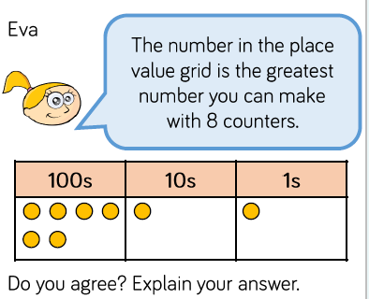

Do you agree? ______________

Why? ________________________________

_____________________________________

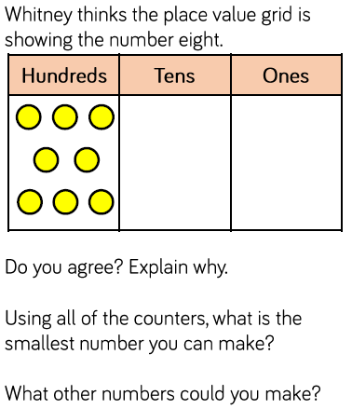

Do you agree? _________ Explain why ____________________________________________________________________________________________________________________________________

Using all of the counters, what is the smallest number you could make?

____________________________________________

What other numbers could you make?

___________________________________________

___________________________________________

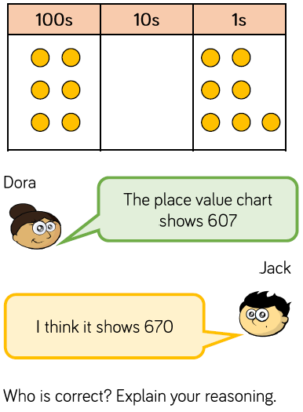

________ because ________________________

_________________________________________

_________________________________________

________________________________________

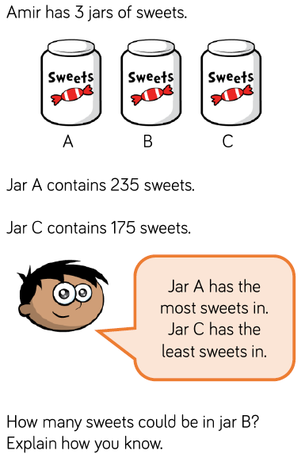

__________________________________

Explain how you know.

_________________________________

_________________________________

_________________________________

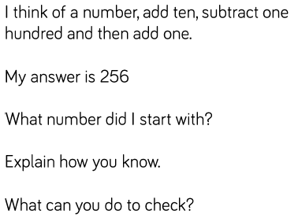

256

?

Explain how you know.

__________________________________________

__________________________________________

__________________________________________

__________________________________________

What can you do to check?

__________________________________________

__________________________________________



__________________________________

Explain how you know.

_________________________________

_________________________________

_________________________________



256

?

Explain how you know.

__________________________________________

__________________________________________

__________________________________________

__________________________________________

What can you do to check?

__________________________________________

__________________________________________