**The Puzzling Sweet Shop**

Rosie went into the sweet shop.

There were chews for 2p, mini eggs for 3p, Chocko bars for 5p and lollypops for 7p.

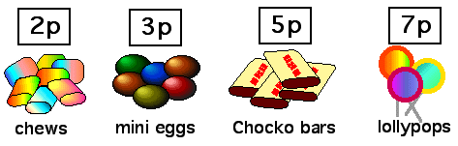

1. Rosie had 10p to spend. What could she buy if she wanted to spend all her money? Can you find more than one possibility?

Alice, James, Katie and Henry went into the shop too.

They each had 20p to spend and they all spent all of their money.

1. Alice bought at least one of each kind of sweet. Which one did she have two of?
2. James spent his money on just one kind of sweet, but he does not like chews. Which sweets did he buy?
3. Katie bought the same number of sweets as James but she had 3 different kinds. Which sweets did she buy?
4. Henry chose 8 sweets. What could he have bought?
5. Annie bought 3 sweets and spent exactly 12p. What did she buy?
6. George wanted to buy 3 mini eggs, 3 chews and a lollypop. He had 20p. Can he afford it? What could he change?
7. Tom had 30p. He bought 6 sweets (all the same) and got 12p change. What did he buy?

**The Puzzling Sweet Shop**

Rosie went into the sweet shop.

There were chews for 2p, mini eggs for 3p, Chocko bars for 5p and lollypops for 7p.



1. Rosie had 10p to spend. What could she buy if she wanted to spend all her money? Can you find more than one possibility?

Alice, James, Katie and Henry went into the shop too.

They each had 20p to spend and they all spent all of their money.

1. Alice bought at least one of each kind of sweet. Which one did she have two of?
2. James spent his money on just one kind of sweet, but he does not like chews. Which sweets did he buy?
3. Katie bought the same number of sweets as James but she had 3 different kinds. Which sweets did she buy?
4. Henry chose 8 sweets. What could he have bought?
5. Annie bought 3 sweets and spent exactly 12p. What did she buy?
6. George wanted to buy 3 mini eggs, 3 chews and a lollypop. He had 20p. Can he afford it? What could he change?
7. Tom had 30p. He bought 6 sweets (all the same) and got 12p change. What did he buy?