**Reach 100**

Here is a grid of four "boxes":

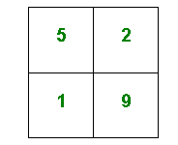You must choose four different digits from 1−9 and put one in each box. For example:

This gives four two-digit numbers:

52 19 51 29

Add them together in pairs. Then add the two numbers.

52 + 19 = 71 51 + 29 = 80 71 + 80 = 151

Try a few examples of your own.  
Is there a quick way to tell if the total is going to be even or odd?

Your challenge is to find four different digits that give four two-digit numbers which add to a total of 100!

How many ways can you find of doing it?