Next step:  Design a meal that will contain food from all 5 food groups. Label which is from each group.  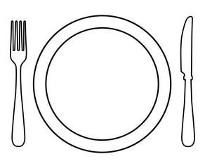  Is it healthy? Why? | Next step:  Design a meal that will contain food from all 5 food groups. Label which is from each group.  Is it healthy? Why?
Next step:  Design a meal that will contain food from all 5 food groups. Label which is from each group.  Is it healthy? Why? | Next step:  Design a meal that will contain food from all 5 food groups. Label which is from each group.  Is it healthy? Why?
Next step:  Design a meal that will contain food from all 5 food groups. Label which is from each group.  Is it healthy? Why? | Next step:  Design a meal that will contain food from all 5 food groups. Label which is from each group.  Is it healthy? Why?

