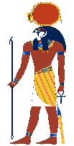 | AMUN
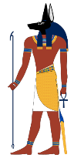 | ANUBIS
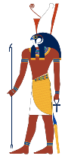 | HORUS
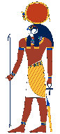 | RA
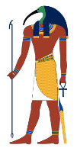 | THOTH
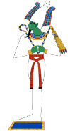 | OSIRIS
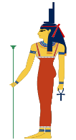 | ISIS
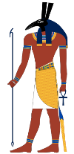 | SETH
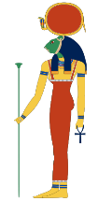 | SEKHMET
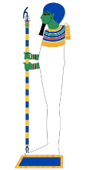 | PTAH
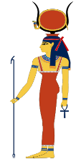 | HATHOR
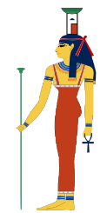 | NEPHTHYS
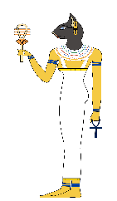 | BASTET

I am ___________. I am the goddess of love, beauty, music and laughter. My name means ‘House of Horus.’ I am shown as being a cow or having horns like a cow. | I am _________. I am the goddess of mourning. I am the sister of Osiris. I helped rebuild Osiris to come back to life. I am always shown with a basket and house on my head. | I am ________. I am the god of the air, sun and the sky. During the New Kingdom, I became the national god of Egypt and merged with Ra, the sun god as Amun-Ra.
I am __________. I am the goddess of Ancient Egyptian religion as well as the home. I had the head of a lioness but over time, this changed to a black cat instead. | I am _________. I am god of death, the underworld and rebirth. I was murdered by my jealous brother Seth. I have green skin and wear a white headdress which looks like a cone. | I am ________. I am the god of the sky and the son of Isis and Osiris. I fought my uncle Seth to become the King of Egypt. I lost an eye. I have the head of a falcon.
I am __________. I am linked to the mummification process. According to the Book of the Dead, I weigh the heart against the Feather of Truth. I have the head of a jackal. | I am _________, also known as Amun-Ra. I am the sun god. I have a circle on top of my head to represent the sun. I look like lots of other gods because I am ‘the father of the gods.’ | I am _________. I have green skin and am a bald headed man. I have a beard and wear tight-fitted clothing so I look a bit like a mummy.
I am ___________. I am the god of knowledge, truth and hieroglyphics. I have the head of an ibis, which is a long and slim bird with a curved beak. | I am __________. I am known as the god of chaos. I murdered my brother Osiris and became the god of darkness. I have a pointed snout and tall rectangular ears. | I am _________. I am a very important god who is in charge of protection. I wear a long dress and a crown which is the hieroglyph for a throne. I am pictured wearing an Ankh.
I am ___________. I am ‘The Great Lady, the holy one, the powerful one.’ I have the body of a woman but the head of a lion. Like Ra, I have a headdress with a sun disk.

