Egyptian Animals

Cats

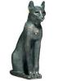In Ancient Egypt every family had a cat, but they were considered too special to be called a pet and they were not given names. The Egyptians thought they were magical and that they were guardians who watched over their homes and families and protected them. They were well fed, hugged and petted and rich Egyptians dressed their cats in precious jewels. It was also a symbol of the cat god Bastet and they represented grace and poise.

They were so important that they were mummified like members of the family.

Scarab beetles

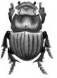The most famous Egyptian insect is the Scarab Beetle. Its Egyptian name is *Kheper* and was associated with the god Khepri*.* Khepri was the god who pushed the sun across the sky, just like the scarab beetle pushes a ball of dung. This meant that the beetle was a symbol for rebirth, as the sun always rises again. When they mummified a body they would usually put a scarab amulet over the heart to help the spirit to be reborn in the afterlife. The symbol was just as important to the Egyptians as the cross is to Christians and they often wore it as an amulet to protect the person from evil.

Crocodiles

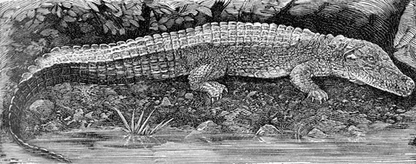The Nile was full of crocodiles! The Egyptians used the Nile for lots of important things and so they had to be very careful about them and showed them respect. The crocodile god was called Sobek and he possessed all the power and strength of a crocodile. The Egyptians respected and worshipped him as he has the power to control the crocodiles and let them use the Nile. The pharaoh also used the symbol of the crocodile to show that he deserved fear and respect.

Ammut was the goddess with a crocodile head and it was she who devoured the heart if it was found to be heavier than a feather by Anubis.

Hippos

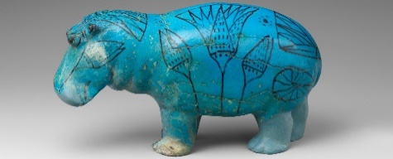The Egyptians were also very scared of hippos. They had huge mouths and teeth, they could be very aggressive and had the power to turn over boats on the Nile or to attack people who were working on the river banks. The goddess Tauret had the symbol of a hippo and she was responsible for birth, so pregnant women would often wear a hippo amulet.

Jackals

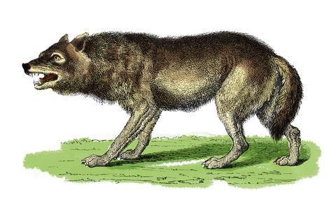Jackals were wild dogs like wolves who the Egpytians has a lot of respect for because they were able to make good decisions. If a jackal found some meat, it was able to tell whether it was good meat to eat or whether it was bad and would make it sick. Anubis had a jackal head, as he was in charge of making the decision whether a dead person had been good enough to enter the afterlife.

Falcons

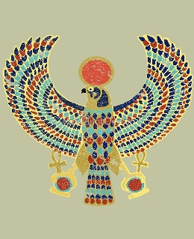Egyptians believed the hawk had powers of protection and links with royalty. They ruled the skies as they flew and protected the Earth with their wings. Hawks were often shown hovering over the pharaoh’s head in pictures.

Both Horus (god of the sky) and Ra (god of the sun) had the head of a falcon or hawk.

Monkeys and Baboons

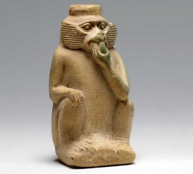Lots of Egyptians kept monkeys as pets and liked to teach them tricks, like how to climb a tree, pick the fruit and throw it down to them. However, they were quite sneaky and would often steal food too!

Baboons were admired for their intelligence. The god Thoth had the head of a baboon and he was in charge of the world of the dead.

Horses

Only very rich people in Egypt had horses. They were used for hunting, wars, parades and pulling chariots.

Farm animals

Farming was very important to the Egyptians and they relied on it to keep themselves fed. Therefore, farming animals were treated well. They used cattle (cows), goats, pigs, ducks, geese and donkeys. Some they used to pull faming machinery like ploughs, and some they used for their meat and milk.

Hathor, Isis and Nut all had cow’s heads, ears or horns because cows were so useful.