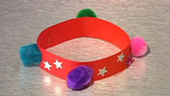
Friendship Bracelet
This should take about 15 minutes

You will need:
- Long strip of coloured, bendy card
- Stickers, coloured pom poms, and anything else to decorate!
- Glue

Method:
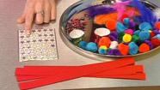 | - Cut out a long, thin strip of card.
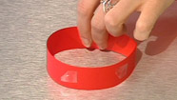 | - Stick the ends of the card together with some glue. This will make the shape of your bracelet.
 | - Decorate with stickers, coloured pom poms, and anything else you would like to use.
 | - Give to a friend.

How to make a bird feeder

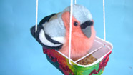
You will need:
- Margarine tub
- Different coloured paper or paint
- Glue
- Hole punch
- Wool

Method:

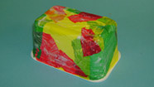 | - Empty the margarine tub.
 | - Decorate it by sticking on pieces of brightly coloured paper. Then wait for it to dry.
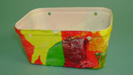 | - Use a hole punch to put four holes in the top of the margarine tub, so that you have two holes facing each other.
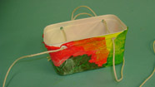 | - Thread some wool through each of the holes, and tie the two ends together.
 | - Finally, fill your birder feeder with bird food.
 | - Hang the bird feeder outside.

Paper Plate Fish

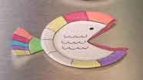
This should take about 15 minutes

You will need:
- White paper plate or round white card
- Scissors
- Glue
- Colouring pens/pencils

Method:
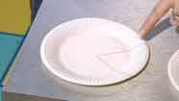 | - Use a ruler and a pencil to draw a triangle on a paper plate.
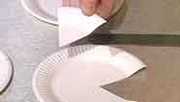 | - Cut out a triangle with some scissors.
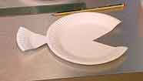 | - Stick the triangle onto the edge of the plate using some glue, to make a fish shape.
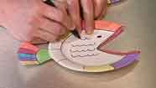 | - Draw some wiggly scales and an eye on the fish, using a black felt tip pen.
 | - Decorate the rest of the fish with bright colours.

Fresh Fruit Lollies
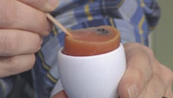
You will need:
- Apron
- Mixing bowl and wooden spoon
- Potato masher
- 2 lolly sticks
- 2 egg cups
- Bowl of strawberries
- Bowl of blueberries
- Orange juice
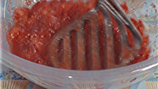 | - Mash up the strawberries using a potato masher.
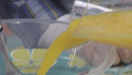 | - Pour in the orange juice and mix together with a wooden spoon.
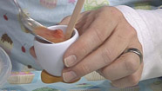 | - Spoon the mixture into the egg cups.
 | - Drop a couple of blueberries into each one.
 | - Put a lolly stick on the side.
 | - Put the egg cups into the freezer and leave for two to three hours.
 | - Once set, lift the fruit lolly out of the egg cup by the lolly stick. Be sure to eat them quickly before they melt!

Table Football

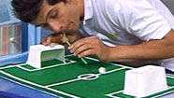
This should take about 30 minutes

You will need:
- Large piece of card
- Green felt (same size as your piece of card)
- Glue or sticky tape
- 2 white margarine tubs
- White tape
- Piece of newspaper
- White paint
- Straw

Method:
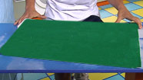 | - Get a large piece of card.
 | - Cut some green felt so that it is the same size as the card and stick it on top. This is your football pitch.
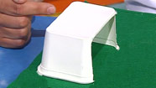 | - Cut out one side of each margarine tub.
 | - Stick them on each side of your football pitch using glue or sticky tape. These will be the goals.
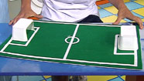 | - Stick white tape to the felt for the markings of the football pitch.
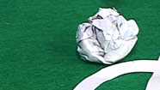 | - Scrunch up a piece of newspaper and paint it white. This will be your football.
 | - Blow through a straw to move the ball around and see how many goals you can score!

