How to Tame a Unicorn

Have you ever wanted a pet unicorn? If the answer is yes, then these are the instructions for you! These instructions give you all the steps needed to tame your very own unicorn.

You will need:

1 wild unicorn

1 bucket

3 cups silver glitter

1tsp liquid sunshine

1 dollop raincloud

Method

1. First, take three cups of silver glitter and sprinkle it into a bucket.

2. Next, add a teaspoon of liquid sunshine.

3. Then, mix a generous dollop of raincloud and combine until smooth.

4. After that, pour the mix at the feet of the unicorn and wait until it starts to eat.

5. Finally, stroke the unicorn’s head gently.

**Be careful not to tread in any unicorn poo!**

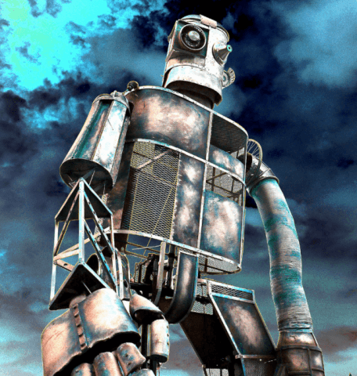**How to Trap the Iron Man**

Are you kept awake by the sound of something tramping through your garden? Do you lie in your bed trembling at the sound of another car being squashed? Do you awake to smashed walls and footprints in the ﬂower beds? Do you live in fear of what might await you round the corner? Do your knees knock at the thought of a walk to the corner shop? If so, the likelihood is that you have the Iron Man in the neighbourhood! Do not despair. Help is at hand. The Iron Man is not so hard to defeat, as they he is rather dim-witted. Read these step-by-step instructions and soon you too could be rid of this terrible pest.

**What you will need:**

* a spade
* a brown sheet
* tent pegs
* a sack of leaves
* some branches
* plenty of soil
* a large lump of metal (maybe a lorry or a tractor)

**What you have to do:**

1. First, dig a very large and deep hole. (This needs to be deep enough to hold the Iron Man.)

2. Secondly, cover the hole with a brown sheet that is pinned securely by tent pegs into the earth’s crust.

3. After that, scatter leaves, a few branches and enough soil on top of the sheet to cover it.

4. Now, tempt the Iron Man by placing a large lump of metal carefully on top of the sheet.

5. Next, hide nearby and patiently wait for his arrival.

6. Then, waft the delicious metallic smell in the direction of the Iron Man.

7. Eventually, the Iron Man will come along and try to get the metal. Keep quiet so you don’t startle him!

8. Finally, watch the Iron Man fall straight into the pit.

**Important note**

An angry Iron Man can be a frightening sight, so keep all little children inside. He will try to escape so make sure that you do not go too near the edge in case he can reach over the top. The Iron Man may try to bargain his way out he may sob and weep and beg for his freedom. He may even promise you vast wealth, pretending that they know the whereabouts of a dragon’s treasure trove. Do not be fooled, the Iron Man only thinks of eating and sleeping.