Imperative Verbs

**TASK ONE**

There are ten sentences below. You need to underline the imperative verb in each sentence.

1. Come here and fold the paper in half.
2. Drive to the hotel.
3. Pour the milk into the bowl.
4. Line up at the door.
5. Take your coats off.
6. Remove the jelly from the mould.
7. Cut along the dotted line.
8. Add the icing to the cake.
9. Close the door after you.
10. Turn right at the traffic lights.

**TASK TWO**

There are another ten sentences below. The imperative words are missing. You need to write out each sentence and make sure you fill in the gap. The sentences can be written in your literacy book.

1. __________ to school every day. It will keep you healthy.

2. __________ the ingredients well in a bowl to make the cake.

3. __________ a match to light the candle.

4. __________ into the balloon to inflate it.

5. __________ an egg in a saucepan to create a delicious breakfast!

6. __________ the cat so she purrs.

7. __________ the ball in a game of basketball.

8. __________ in the park.

9. __________ water to keep you hydrated, especially in the summer when it is hot.

10. __________ at the weekend because you deserve a rest.

[](http://www.google.co.uk/url?sa=i&source=images&cd=&cad=rja&docid=gWKYDpNcOWSyVM&tbnid=A7iHIO4hkaT6HM:&ved=0CAgQjRwwAA&url=http://mrmen.wikia.com/wiki/Mr._Chatterbox&ei=PBJjUaioH-fY0QWAwYGwBA&psig=AFQjCNGd2TO26vGJJ6MIXSRDLX-EZ1Q4jA&ust=1365533628553284)Imperative Verbs

**TASK ONE**

Mr. Chatterbox has made all Little Miss Bossy’s sentences too long! They don’t sound bossy anymore! Can you help Little Miss Bossy cut out words to turn them into sentences with bossy verbs? Remember! Bossy verbs and sentences sound like commands and instructions.

1. Please could you come over and fold the paper in half?
2. Could you carefully drive to the hotel?
3. Please pour the milk into the bowl.
4. When you are ready, line up at the door.
5. Take your coats off, but please do it carefully.
6. Gently remove the jelly from the mould.
7. If you want to, cut along the dotted line.
8. When you have time, add the icing to the cake.
9. Please close the door after you.
10. I think you should turn right at the traffic lights, don’t you?

**TASK TWO**

Use the class word bank of imperative verbs to come up with 10 sentences. Your sentences should be bossy!

Imperative Verbs

**TASK ONE**

There are ten sentences below. You need to add to these sentences in order to help Mr Bossy find his manners. Little Miss Manners isn’t happy with him being so bossy.

1. Come here and fold the paper in half.
2. Drive to the hotel.
3. 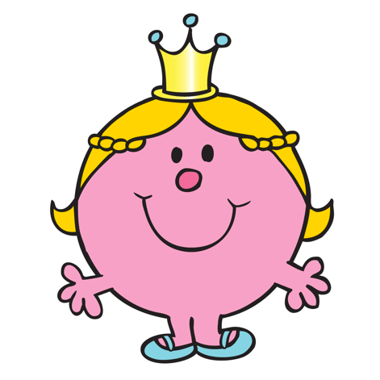Pour the milk into the bowl.
4. Line up at the door.
5. Take your coats off.
6. Remove the jelly from the mould.
7. Cut along the dotted line.
8. Add the icing to the cake.
9. Close the door after you.
10. Turn right at the traffic lights.

**TASK TWO**

Are there any words that haven’t been included in the class imperative verb word bank? See if you can think of 10 different ones. Once you have, write bossy sentences using each imperative verbs you have created.