This pictogram shows which car a group of people would most like to have = 1 person
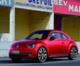
Beetle

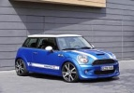
Mini
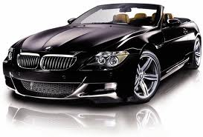
BMW
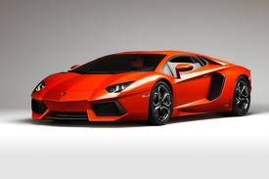
Lamborghini
Range Rover
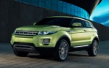

How many people like to have a Beetle? __________
How many people would like to have a Lamborghini? __________
How many people would like to have a Mini? ____________
How many people would like a Range Rover and BMW altogether?________
Which is the most popular car?_________
Which is the least popular car? _________
How many more people would like a BMW than a Mini?_________
How many people were asked altogether? __________
How many people did not want a Beetle?______________

