The pictogram shows the favourite pizza types of children in a class.

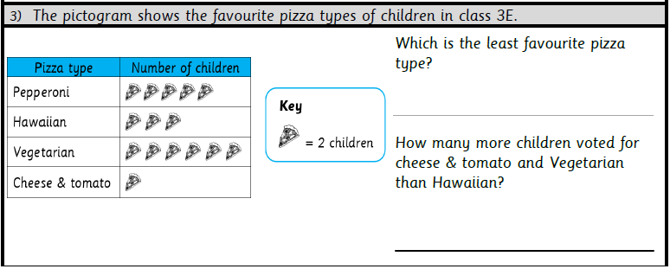Which was the least popular?

How many children chose pepperoni?

How many more children chose vegetarian than cheese and tomato?

How many children were asked?

The pictogram shows the favourite pizza types of children in a class.

Which was the least popular?

How many children chose pepperoni?

How many more children chose vegetarian than cheese and tomato?

How many children were asked?

The pictogram shows the favourite pizza types of children in a class.

Which was the least popular?

How many children chose pepperoni?

How many more children chose vegetarian than cheese and tomato?

How many children were asked?

The pictogram shows eye colour of a class of children.

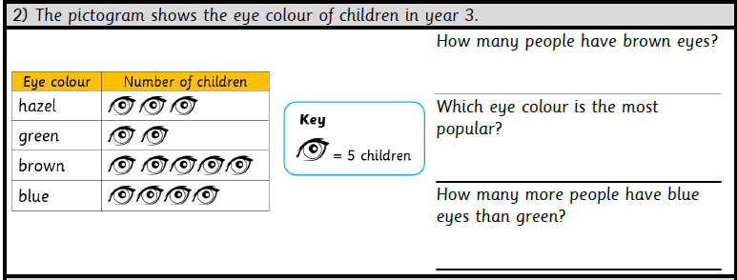How many children had blue eyes?

Which colour eyes did the most children have?

How many more children had brown eyes than green?

How many children had green or hazel eyes?

How many children were asked?

The pictogram shows eye colour of a class of children.

How many children had blue eyes?

Which colour eyes did the most children have?

How many more children had brown eyes than green?

How many children had green or hazel eyes?

How many children were asked?

The pictogram shows eye colour of a class of children.

How many children had blue eyes?

Which colour eyes did the most children have?

How many more children had brown eyes than green?

How many children had green or hazel eyes?

How many children were asked?

The pictogram shows the number of ice creams that were eaten on a Saturday.

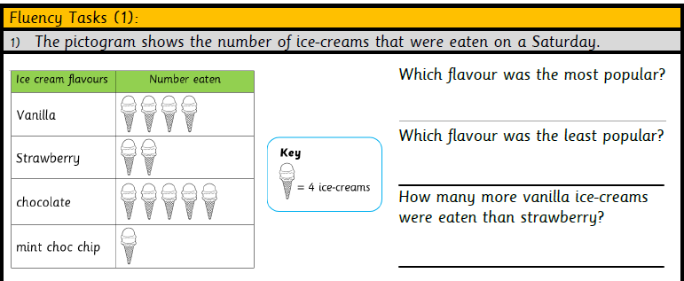Which flavour was the most popular?

How many children chose strawberry?

How many chose vanilla or chocolate?

How many more chose chocolate than mint?

How many fewer chose strawberry than vanilla?

How many ice creams were eaten in total?

Do you think as many would be eaten on a Monday? Why?

The pictogram shows the number of ice creams that were eaten on a Saturday.

Which flavour was the most popular?

How many children chose strawberry?

How many chose vanilla or chocolate?

How many more chose chocolate than mint?

How many fewer chose strawberry than vanilla?

How many ice creams were eaten in total?

Do you think as many would be eaten on a Monday? Why?

The pictogram shows the number of ice creams that were eaten on a Saturday.

Which flavour was the most popular?

How many children chose strawberry?

How many chose vanilla or chocolate?

How many more chose chocolate than mint?

How many fewer chose strawberry than vanilla?

How many ice creams were eaten in total?

Do you think as many would be eaten on a Monday? Why?