WALT- read and answer questions about a pictogram.
This pictogram shows how a class of Year 6 children travel to school.
= 2
walk

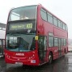
bus
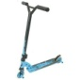
scooter
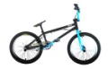
bike
car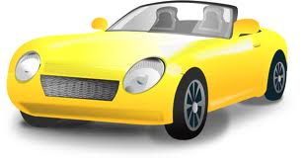

How many children travel by scooter? _______
How many children travel by car? __________
Which is the least popular way of travelling to school?_______
Which is the most popular way of travelling to school?_______
How many children walk and travel by bike altogether?_______
How many more children travel by scooter than on a bus?______
How many children are there altogether?_______
2 new children join the class and they travel by bus. Show this on the pictogram.

