Drawing Pictograms

1. 20 people were asked what colour their eyes are, here are the results:
Blue Brown Green Blue
Brown Brown Blue Other
Blue Green Other Brown
Green Other Blue Brown
Brown Brown Blue Brown

Number of Blue: Brown: Green: Other: 3

Now use the key to put the information onto the pictogram

Key:
=2

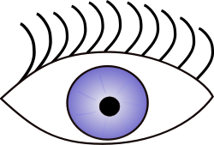

Blue
Brown
Green
Other

2. At a local school staff were asked what their favourite drink at school is, here are the results:

Coffee Tea Milk Water
Tea Tea Coffee Tea
Water Coffee Tea Milk
Coffee Coffee Coffee Tea
Water Tea Coffee Milk

Number of Coffee: Tea: Water: Milk:

Coffee | Key:
Tea
Water
Milk

Decide on a suitable key and fill in the chart

3. A group of students were asked what their favourite film genre is, here are the results:

Horror Comedy Thriller Animated
Comedy Comedy Fantasy Rom-com
Animated Horror Rom-com Thriller
Fantasy Comedy Horror Rom-com
Comedy Thriller Fantasy Animated
Rom-com Horror Comedy Comedy

Draw a table:

Using these results construct your own pictogram.

