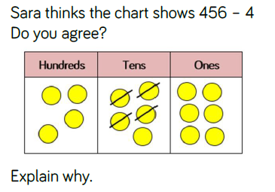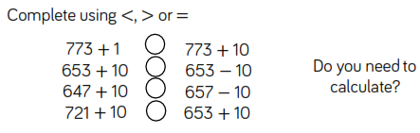

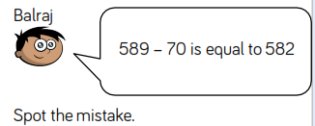

Is he right?____________________

Explain why.

________________________________________________________________________________________________________________________________

Here are two subtraction questions. Before you calculate, can you tell by looking whether you will have to borrow? How?

1. 56 – 34
2. 27 – 19

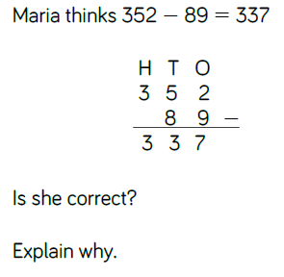

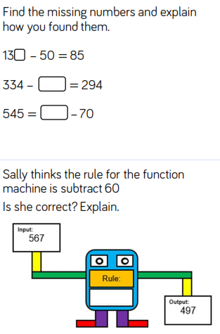

Find the missing number:

296 + _____ = 546

_____ + 319 = 623

How many different ways can you write a subtraction question using these 4 digits so that the answer will end in 4?

**7 5 3 9**

