|  |  |  |
| --- | --- | --- |
| Next step  Fill in the gaps.  What was the original question? | Next step  Fill in the gaps.  What was the original question? | Next step  The answer is 288.  Fill in the gaps.  What was the original question? |
| Next step  Fill in the gaps.  What was the original question? | Next step  Fill in the gaps.  What was the original question? | Next step  The answer is 288.  Fill in the gaps.  What was the original question? |
| Next step  Fill in the gaps.  What was the original question? | Next step  Fill in the gaps.  What was the original question? | Next step  The answer is 288.  Fill in the gaps.  What was the original question? |
| Next step  Fill in the gaps.  What was the original question? | Next step  Fill in the gaps.  What was the original question? | Next step  The answer is 288.  Fill in the gaps.  What was the original question? |
| Next step  Fill in the gaps.  What was the original question? | Next step  Fill in the gaps.  What was the original question? | Next step  The answer is 288.  Fill in the gaps.  What was the original question? |

|  |  |  |
| --- | --- | --- |
| Next step  Fill in the gaps.  What was the original question? | Next step  Fill in the gaps.  What was the original question? | Next step  The answer is 288.  Fill in the gaps.  What was the original question? |
| Next step  Fill in the gaps.  What was the original question? | Next step  Fill in the gaps.  What was the original question? | Next step  The answer is 288.  Fill in the gaps.  What was the original question? |
| Next step  Fill in the gaps.  What was the original question? | Next step  Fill in the gaps.  What was the original question? | Next step  The answer is 288.  Fill in the gaps.  What was the original question? |
| Next step  Fill in the gaps.  What was the original question? | Next step  Fill in the gaps.  What was the original question? | Next step  The answer is 288.  Fill in the gaps.  What was the original question? |
| Next step  Fill in the gaps.  What was the original question? | Next step  Fill in the gaps.  What was the original question? | Next step  The answer is 288.  Fill in the gaps.  What was the original question? |

Next step

Fill in the gaps.

What was the original question?

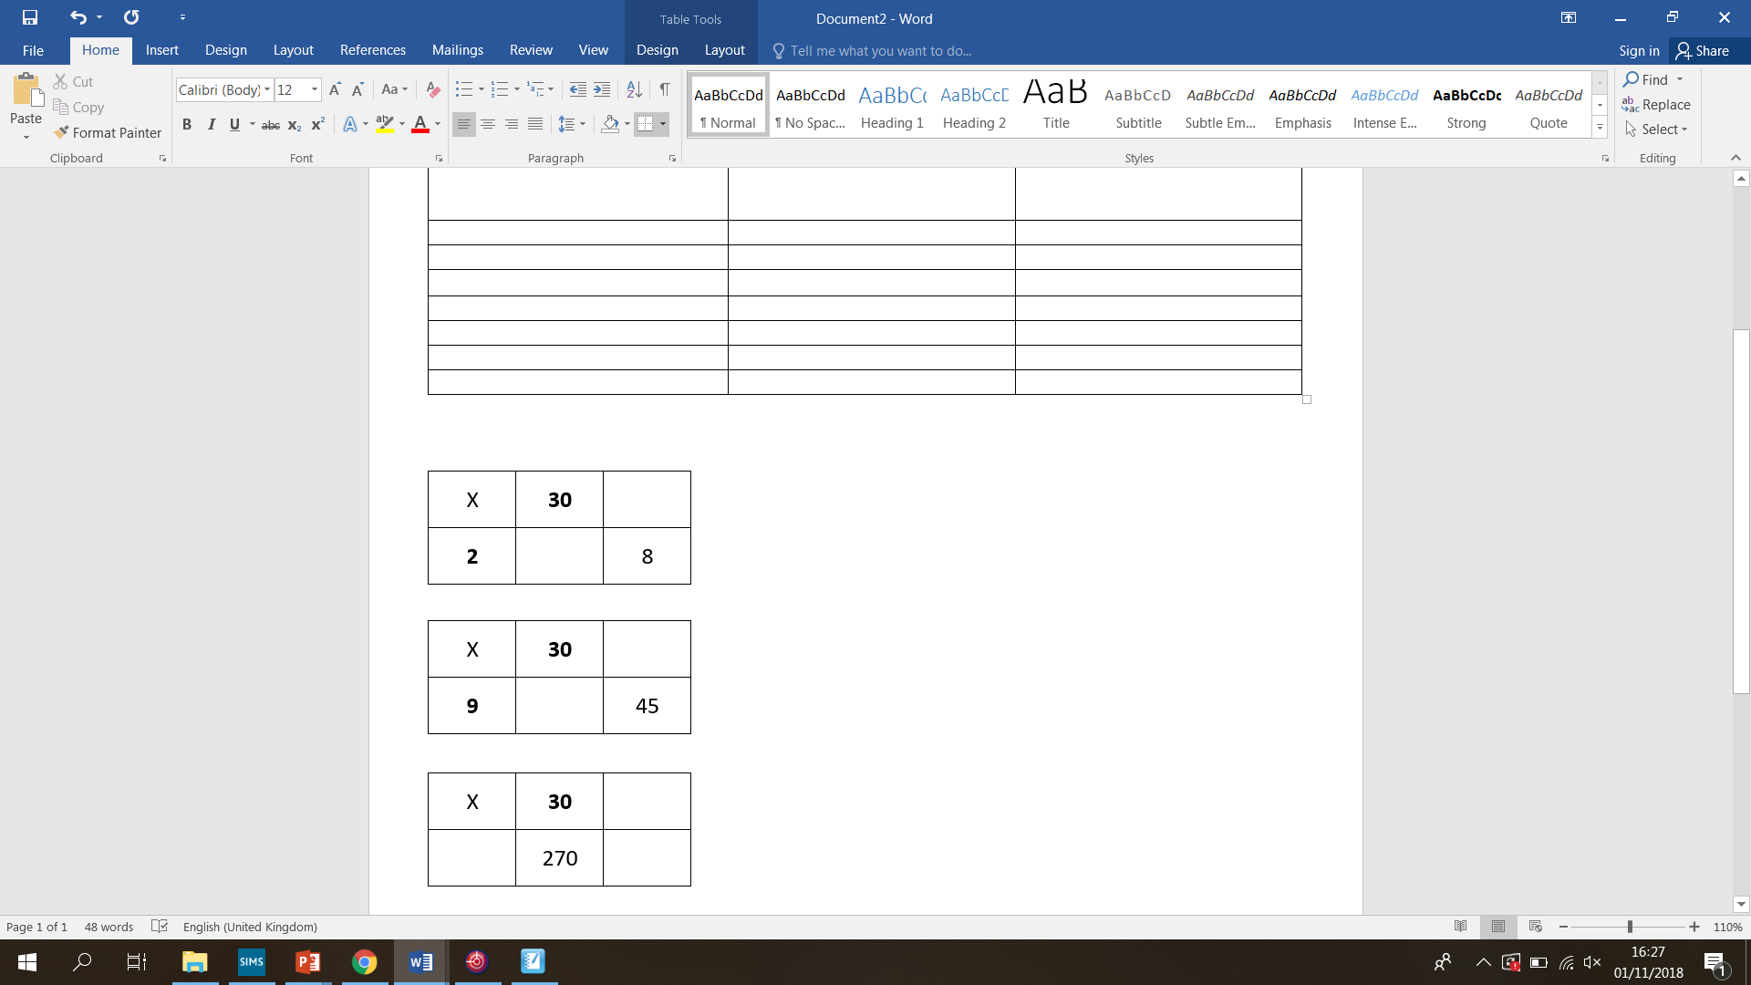

Next step

Fill in the gaps.

What was the original question?



Next step

Fill in the gaps.

What was the original question?



Next step

Fill in the gaps.

What was the original question?



Next step

Fill in the gaps.

What was the original question?

