**The Digestive System**

Label the different parts of the Digestive System. With each label, write a sentence or two about what happens in that part of the body.

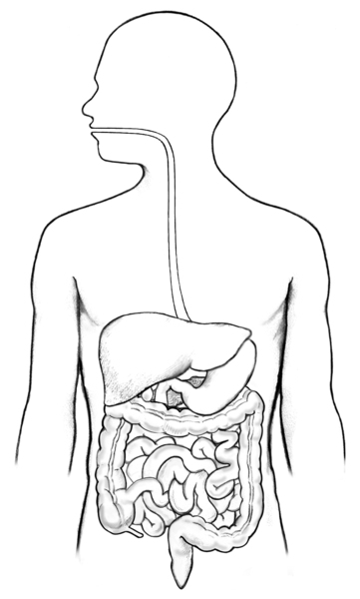Example: **Mouth:** When the food enters the mouth, the teeth chew the food which mixes with saliva ready to swallow.