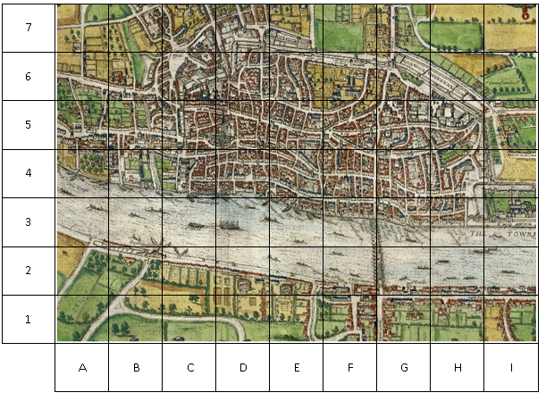

Mark the parts of London in the Great Fire of London

|  |  |  |
| --- | --- | --- |
| **Use this symbol** | **Name of area** | **Grid reference** |
| Image result for candle flame clipart | Pudding Lane | **G4**  (the small vertical road in the left corner) |
| Cheese clipart 2 | Seething Lane (home of Samuel Pepys) | **H4** |
| Image result for simple bridge clipart | London Bridge | **F3** to **G2** |
| Related image | Spital Fields | **H7** |
| Related image | Moor Fields | **F7** |
| Image result for tower outline | Tower of London | **I3** |

Colour the following squares red to show where the fire spread: **B4, B5, C4, C5, D4, D5, D6, E4, E5, E6, F3, F4, F5, G3, G4, H3**