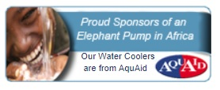

Here, at **Shenfield St Mary's C of E Primary School**, we are aware that keeping our children and staff hydrated will aid them to perform at their very best throughout the school day.

As a result, we decided to invest in a water cooler from AquAid.

Our unique relationship with **AquAid** has also given our School the opportunity to help those less fortunate than ourselves, because with each purchase an automatic donation is made to the **Africa Trust**.

These funds are used to build ‘Elephant Pumps’ - a modified version of an age old Chinese rope pulley system. One such pump is currently being installed in Africa on our behalf and it will be a much needed source of clean and fresh drinking water for many.

Our School’s name will be proudly displayed on our well and we look forward to adding a photo, a certificate and a letter of thanks from the villagers to our website in the near future.

To date AquAid have built over 8,000 such Elephant Pumps across parts of Liberia, Malawi, Mozambique and Zimbabwe; and have donated in excess of £15 million to charity.

