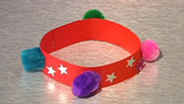
Friendship Bracelet
This should take about 15 minutes

You will need:
- Long strip of coloured, bendy card
- Stickers, coloured pom poms, and anything else to decorate!
- Glue

Method:
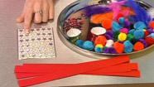

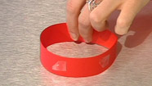

How to make a bird feeder

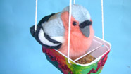
You will need:
- Margarine tub
- Different coloured paper or paint
- Glue
- Hole punch
- Wool

Method:

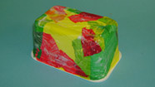

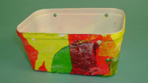

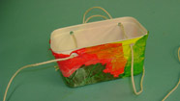

Paper Plate Fish

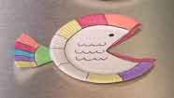
This should take about 15 minutes

You will need:
- White paper plate or round white card
- Scissors
- Glue
- Colouring pens/pencils

Method:
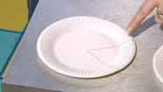

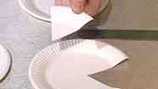
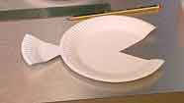
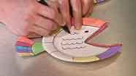

Fresh Fruit Lollies
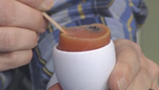
You will need:
- Apron
- Mixing bowl and wooden spoon
- Potato masher
- 2 lolly sticks
- 2 egg cups
- Bowl of strawberries
- Bowl of blueberries
- Orange juice
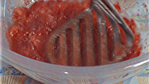
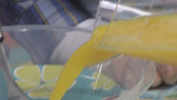

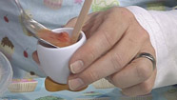

Table Football

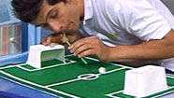
This should take about 30 minutes

You will need:
- Large piece of card
- Green felt (same size as your piece of card)
- Glue or sticky tape
- 2 white margarine tubs
- White tape
- Piece of newspaper
- White paint
- Straw

Method:
