**MY NEW YEAR RESOLUTION**

HOME:

Eat more fruits and vegetables and consume less junk food

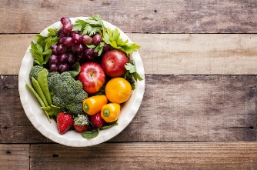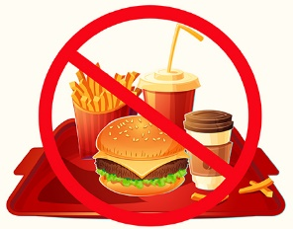

Clean my room every day without my mom’s help.

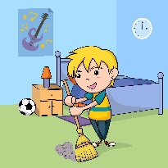

SCHOOL:

Learn 5 new words daily from Dictionary

Read more books 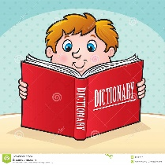

Improve my descriptive writing skills 

COMMUNITY:

Walk to nearby places to prevent pollution  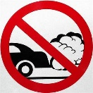

Meet new people and make more friends in my neighbourhood 