**My New Year’s Resolutions 2021 by Ben Wood**



**Home**: **I want to always be kind to my sister**

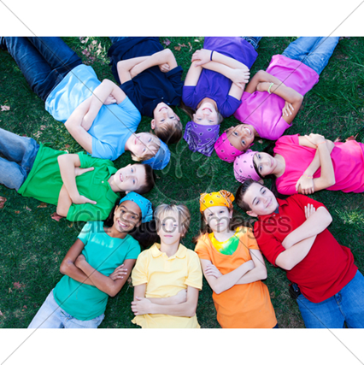

**School: I would like to make more friends at school in my class**



**Community: I would like to fight racism by treating everyone equally**