13.1.20

Can I solve a money problem?

Jamie selects four of these coins.

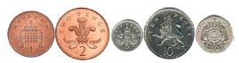

He can use the coins more than once.

What total could he make?

What is the lowest total?

What is the greatest total?