Weekly Work - Home Learning for Self Isolating Pupils
Class: Dragonfly and Ladybird | Week Beginning: 5th October 2020

Literacy | Can I write an acrostic poem?  Write your own acrostic poem (like we did last week) using the word Autumn. | Can I identify features of a diary?  Look at and discuss the powerpoint about features of a diary.  Read the extracts from Samuel Pepys’ diary and identify the diary features. Complete the comprehension questions based on the diary extracts. | Can I write a diary entry based on a familiar story?  Recap the features of a diary and write a day’s diary entry from the point of view of one of the Three Little Pigs. Use the Diary Writing Checklist to check the key features are included. | Can I order the events of Diary of a Killer Cat?  Read the book ‘Diary of a Killer Cat’ and discuss the features of a diary. Identify the key events of each day. In school the children are doing this verbally in groups and then putting the days together. | Can I describe a character’s feelings and how they change?  Read the story of ‘Diary of a Killer Cat’. https://www.youtube.com/watch?v=-A1WrVjpbU8 Draw a picture of Ellie and Tuffy the cat and write sentences around the pictures explaining how they feel.
Numeracy | Can I solve mixed word problems?  Complete the following word problems. Drawing the tens and ones to add or take away the numbers. | Can I add using place value grids?  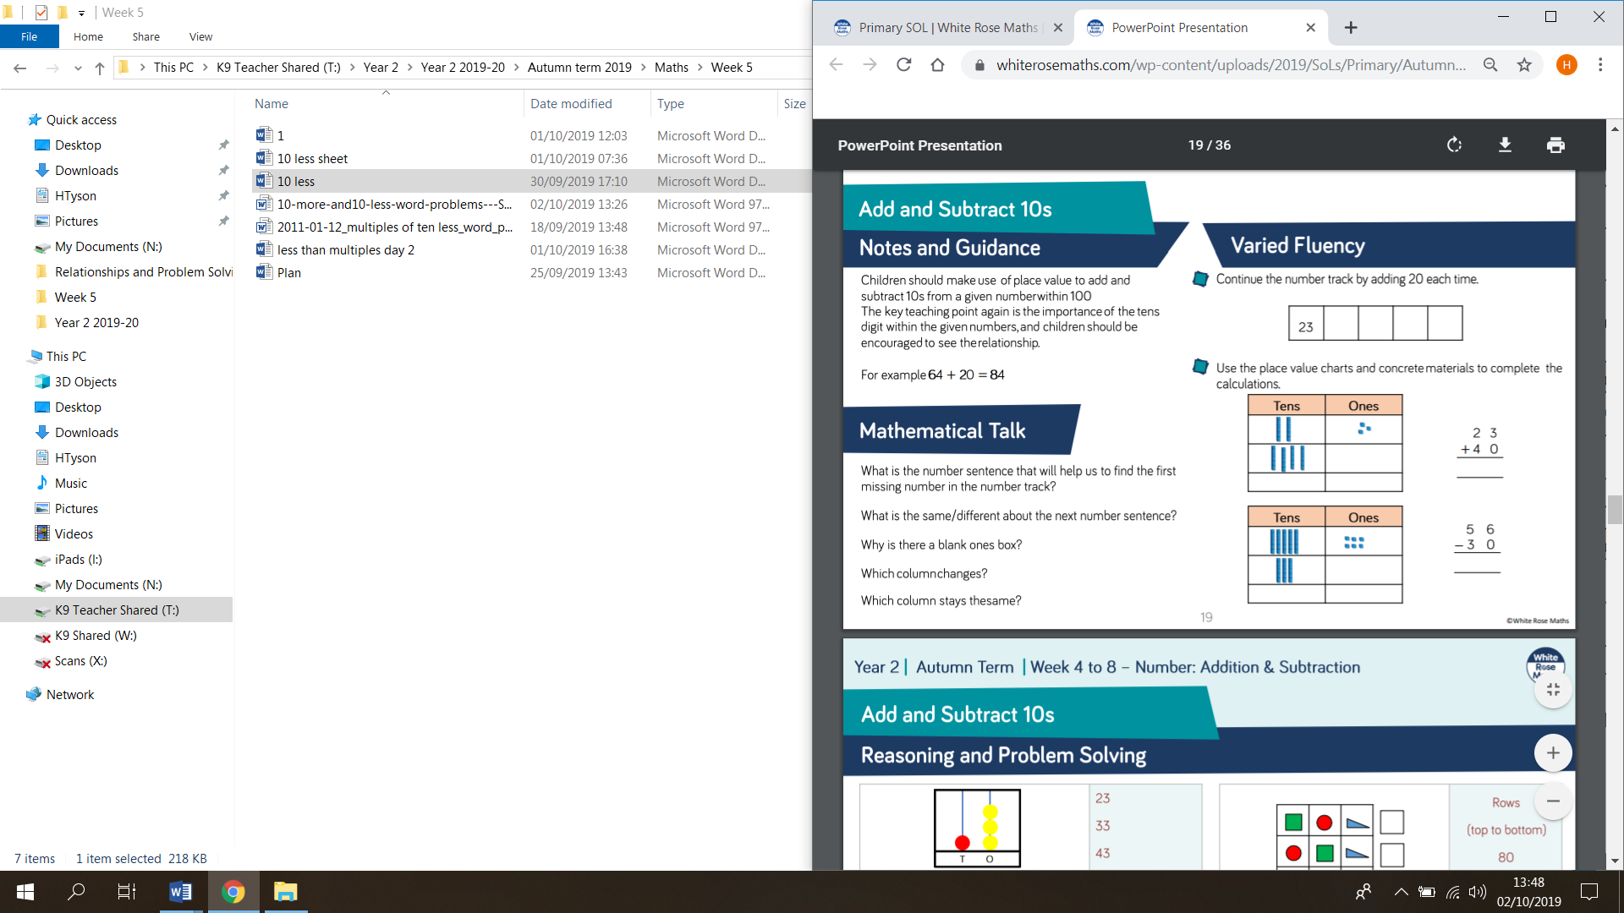use the example above to add a 2 digit number and a tens number. Roll a dice to make the 2 digit number and then add the tens. Add them together by drawing in the place value box like above. | Can I add using place value grids?  Show them the place value grids (the same as yesterday) Show alongside it the column addition and write the column addition method alongside the place value grid. | Can I add ones using place value grids?  Using place value grids and get them to add a 2-digit number and a 1 digit number e.g. 24 + 5=. Complete the place value grids and also write as a column addition | Can I add two digit numbers using place value grids?  Discuss how to add both ones and tens together. Draw the numbers using place value grids and then write also as a column addition.
Science | Can I investigate which material is most waterproof? Put a lego person (or other item) in each of 3 cups and then put a different material over the top of each cup and secure. Then pour the same amount of water over each cup and record which person is the wettest.
RE | Can I explain what I find fascinating about the natural world and what I would ask God about creation? Children draw 2 pictures to show 2 parts of creation that they are fascinated by and write down why they are. E.g. I am fascinated by the snowflakes because they are all different shapes and can fall both fast and slow. Then write and draw 2 questions they would ask God about creation e.g. how far do stars go into space and how bright are they?
Topic | Can I recognise people’s reactions? Think about how people might have felt across the days of the fire spreading. Think about what they saw and how they felt for each of the relevant days. Then create a news report describing the events of the fire (you may want to record it).
PE | Design and run your own PE training circuit. You may want to use ideas from a Joe Wicks video to think of 4 different exercises or activities  to add to your circuit.
Art | Can I investigate a range of collage materials?  Collect rubbings around the school- think about which work well and why? Try adding crayon, pastel or colouring pencils to make the buildings look more realistic.

