The Sun

Monday 5th March 50p
Hubbard’s historic house has horrific burglary!!!
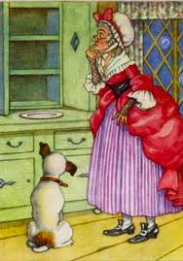

By Josh, Maisie and Connor.

On Sunday morning, an elderly woman was left shivering after she went to the cupboard in her historic house to fetch her doggie a bone, only to find out she had been burgled!!!

Old Mother Hubbard and her dog.
On Sunday 4th of March, Miss Matilda Hubbard, 55, went to fetch her dog Mollie her breakfast bone. However she felt shocked and upset after seeing the bare state of her cupboard.

“I felt sorry and sad after seeing my dog whimpering because I knew she was hungry,” she explained. “I couldn’t stop crying!!”

Mickey and Minnie, aged 8 and 9, were just walking past the historic house at the time of the burglary and witnessed the whole event. “It was a horrible sight!” exclaimed Mickey. “We saw a strange man all dressed in black. He looked very suspicious, I knew he was up to no good,”
explained Minnie Mouse.

Mickey added, “Fortunately we were quick enough to contact the police before any major damage was done.”

At first Miss Hubbard had no idea what had happened. She felt very confused and started to panic.

“I almost fainted when I suddenly realised I had been burgled. Who would want to rob a poor old lady and her doggie?”

Police are now questioning a middle aged man from the local area, and are close to finding out who committed the crime.

