Sutton Hoo

Why is this place famous?

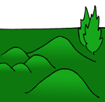Sutton Hoo is a place in Suffolk.

* In the [Dark Ages](http://www.earlybritishkingdoms.com/kids/dark_ages.html) & [Saxon](http://www.earlybritishkingdoms.com/kids/sax.html) times, it was in the Kingdom of [East Anglia](http://www.earlybritishkingdoms.com/kids/eastanglia.html).
* There is a field in the village with lots of big bumps in the ground. Some are quite large, like small hills.
* No-one knew how old the mounds were, but they thought they probably had people buried inside them.
* In Tudor times, treasure hunters had dug a big hole into the biggest mound, but they didn't find much.
* 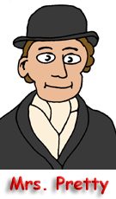Before the Second World War, the land was owned by a lady named Mrs. Edith Pretty. She was very interested in history.
* In 1939, she let a group of archaeologists excavate the main big mound. They were led by Basil Brown a self taught Suffolk archaeologist. Later Charles Phillips from Cambridge University whose team included Stuart Piggott and Peter Grimes.
* They found that it was Saxon and contained lots of [armour](http://www.earlybritishkingdoms.com/kids/sutton_helm.html), [weapons](http://www.earlybritishkingdoms.com/kids/sutton_weapons.html), [jewellery](http://www.earlybritishkingdoms.com/kids/sutton_jewellery.html), [symbols of power](http://www.earlybritishkingdoms.com/kids/sutton_symbols.html) and [other treasures](http://www.earlybritishkingdoms.com/kids/sutton_treasures.html). Gold, gold and more gold!
* All these things were found inside the remains of a huge wooden [ship](http://www.earlybritishkingdoms.com/kids/sutton_ship.html) which had been buried under the mound.
* But there was [no body](http://www.earlybritishkingdoms.com/kids/sutton_body.html)!
* This was the greatest archaeological discovery ever made on British soil.
* All the things found can be seen in the [British Museum](http://www.thebritishmuseum.ac.uk/compass/ixbin/hixclient.exe?_IXDB_=compass&_IXFIRST_=1&_IXMAXHITS_=1&_IXSPFX_=graphical/edu/gt/lin/&_IXtour=ENC11472&$+with+all_unique_id_index+is+$=ENC11472&submit-button=summary) in London.

The Sutton Hoo Ship

How do we know it was there?

* Before Victorian times, ships were always made of wood. Wood rots when it is put in the ground. So how do we know about the [Sutton Hoo](http://www.earlybritishkingdoms.com/kids/sutton_hoo.html) ship?
* The type of sand in the soil at Sutton Hoo is very unusual. When things rot in it, they can leave their shape in the soil.
* It looks like a dark stain. This can be excavated if you are very careful. This was what happened in 1939.
* Look at the picture. The photographer is standing at one end of the ship, looking towards the other end. You can easily see the planks which the ship was made of.
* You can also see lines of dots in the picture. These are the iron rivets which held the planks together.
* The ship was 90ft long.
* The archaeologists could also see patches on the ship's hull. So the ship was not new when it was buried. It had been to sea and had been repaired.
* It does not seem to have had a mast or a sail. It was rowed by men with oars. There were probably 28 of them.
* It had a big triangular wooden chamber in the centre - like half a tube of toblerone. This was where the [dead person](http://www.earlybritishkingdoms.com/kids/sutton_body.html)'s [possessions](http://www.earlybritishkingdoms.com/kids/sutton_hoo_index.html) were found.
* The ship had probably been dragged to Sutton Hoo, on rolling logs, from the nearby River Deben.
* Another ship burial had been discovered at 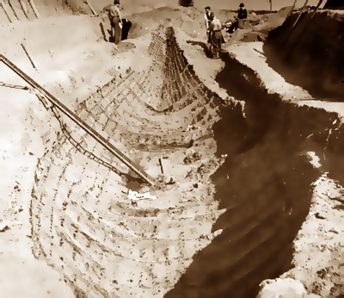Snape, only 9 miles away, in 1862. Viking ship burials have been found in Norway too; and there were [other ship burials](http://www.earlybritishkingdoms.com/kids/sutton_mounds.html) in the mounds at Sutton Hoo.
* The '[Beowulf](http://www.earlybritishkingdoms.com/kids/beowulf_poem.html)' poem [tells of a ship funeral](http://www.earlybritishkingdoms.com/kids/beowulf_quotes.html#ship). The ship was not buried, but sent out to sea.

Mysterious Missing Body

Was there a body in the famous ship?

* When archaeologists discovered the famous [ship burial](http://www.earlybritishkingdoms.com/kids/sutton_ship.html) at [Sutton Hoo](http://www.earlybritishkingdoms.com/kids/sutton_hoo.html), they didn't find a skeleton.
* Some people think that the ship was just a memorial. There was never anyone buried there. This is called a 'cenotaph'.
* However, the soil at Sutton Hoo is very acidic. A skeleton can dissolve in very acidic soil. This is very unusual though. It disappears, like sugar dissolving in water.
* Archaeologists think that the boat caught rainwater and formed a big acidic bath.
* They have tested the soil where they would expect to find a body. It contained chemicals which probably came from a dissolved body.
* The [dead person](http://www.earlybritishkingdoms.com/kids/sutton_who.html) seems to have been buried in a large wooden coffin called a 'sarcophagus'.

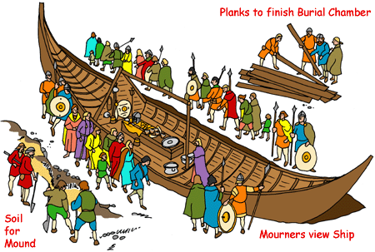

|  |
| --- |
| The Sutton Hoo Helmet  The Helmet   * In the [ship burial](http://www.earlybritishkingdoms.com/kids/sutton_ship.html) at [Sutton Hoo](http://www.earlybritishkingdoms.com/kids/sutton_hoo.html), a tunic of iron chain mail was folded in the [dead person](http://www.earlybritishkingdoms.com/kids/sutton_body.html)'s sarcophagus (big coffin). It was probably thigh length, but had rusted into a big lump of metal. * The helmet was placed on top of the sarcophagus. It was at the head end. * Most of the helmet was made of iron. It rusted in the ground. Only small parts were left (the rough bits in the picture). * Archaeologists had to piece these together It was like a giant jigsaw puzzle. Except most pieces were missing. |
| * The helmet was covered in small [decorated panels](http://www.earlybritishkingdoms.com/kids/sutton_helm_panels.html). These were made of tin covered bronze foil. It would originally have all looked very silver in colour. * It had a long iron neck-guard at the back. * The crest went over the middle of the head. It was shaped like a dragon and made of gold covered bronze. The dragon had garnets (red jewels) for eyes. * The helmet has big bronze eyebrows. They end in tiny boars' heads and are lined with garnets. * Hanging from the helmet were a mask to protect the face; and flaps to protect the ears and jaw. * The face mask has a gold covered bronze nose and moustache. * The helmet is thought to have had a leather lining. * It would have taken a long time to make. It would have been very expensive. * Similar Viking helmets have been found by archaeologists in Sweden. * http://www.earlybritishkingdoms.com/kids/images/sutton_helmet.jpgSimilar [helmets are mentioned](http://www.earlybritishkingdoms.com/kids/beowulf_quotes.html#armour) in the '[Beowulf](http://www.earlybritishkingdoms.com/kids/beowulf_poem.html)' poem. | |

Sutton Who?

Who was buried there?

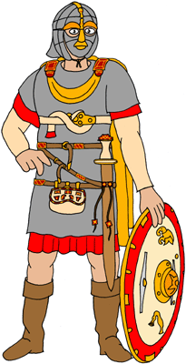The [weapons](http://www.earlybritishkingdoms.com/kids/sutton_weapons.html) and [armour](http://www.earlybritishkingdoms.com/kids/sutton_helm.html) found in the [ship burial](http://www.earlybritishkingdoms.com/kids/sutton_ship.html) at [Sutton Hoo](http://www.earlybritishkingdoms.com/kids/sutton_hoo.html) show that the dead person was a man.

This man owned a big ship. He was buried in it. This shows he was a [pagan](http://www.earlybritishkingdoms.com/kids/pagan_saxons.html).

He had possessions covered in [gold and jewels](http://www.earlybritishkingdoms.com/kids/sutton_jewellery.html). This shows he was very rich.

He possessed spoons which might have been Christian objects.

He also had things which had come [from a long way away](http://www.earlybritishkingdoms.com/kids/sutton_treasures.html). This shows he had lots of contacts abroad.

* The man owned what seems to be a [standard and a sceptre](http://www.earlybritishkingdoms.com/kids/sutton_symbols.html). These show he was very powerful.
* This rich and powerful man may have been a king. The Kings of [East Anglia](http://www.earlybritishkingdoms.com/kids/eastanglia.html) are thought to have lived at Rendlesham. This is not far from Sutton Hoo.
* Some of the coins in the dead man's [purse](http://www.earlybritishkingdoms.com/kids/sutton_jewellery.html) were made in AD 625. This shows he must have died after that date.
* There was a King of East Anglia who died some time between AD 617 and AD 631. His name was [Redwald](http://www.earlybritishkingdoms.com/kids/eastanglia.html#redwald). He became a Christian, but was still keen on pagan ways. It was probably Redwald who was buried in the great Sutton Hoo ship burial.

Why bury all that stuff?

In Saxon Graves at Sutton Hoo and other places?

* [Pagan Saxons](http://www.earlybritishkingdoms.com/kids/pagan_saxons.html) believed that, after they died, they would live on in a different place. This is called an 'After-Life'. Many different religions have similar beliefs.
* The [Saxons](http://www.earlybritishkingdoms.com/kids/sax.html) believed they would need lots of belongings in this new life. The richer and more important the person, the more things they would need.
* If archaeologists find a grave containing a body with lots of possessions, they know that the dead person was a pagan.
* Some bodies are found with coins. These were to pay the ferryman who would ferry the dead person across the sea to their afterlife.
* Most dead people would walk to the ferry. The dead man in [Mound 17](http://www.earlybritishkingdoms.com/kids/sutton_mounds.html) at [Sutton Hoo](http://www.earlybritishkingdoms.com/kids/sutton_hoo.html) had his horse to carry him.
* The [man buried](http://www.earlybritishkingdoms.com/kids/sutton_who.html) in the big famous mound at Sutton Hoo had his own [ship](http://www.earlybritishkingdoms.com/kids/sutton_ship.html) buried with him so it could carry him to the afterlife. He still had to pay for the oarsmen to row him though.
* Some people think that the 40 coins in his [purse](http://www.earlybritishkingdoms.com/kids/sutton_jewellery.html) were to pay for 40 oarsmen. The two small gold bars were to pay the pilot and the steersman.

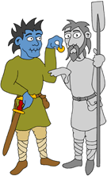

More Sutton Mounds

Stolen treasure at Sutton Hoo

* The famous [ship burial](http://www.earlybritishkingdoms.com/kids/sutton_ship.html) at [Sutton Hoo](http://www.earlybritishkingdoms.com/kids/sutton_hoo.html) was discovered under a mound called 'Mound 1'. There are about twenty other burial mounds in the same field.
* Mound 1 is the biggest mound. Mound 2 is also very big. The others are smaller.
* Several of these other mounds have been excavated by archaeologists.
* Sadly, most of them had been robbed by treasure hunters. This probably happened in Tudor times.
* 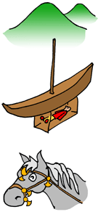The robbers didn't do a very good job. Archaeologists have found small things which they missed. They also use clever techniques to work out what metals have been buried in the ground.
* Mound 2 contained another big ship. The dead person was buried in a wooden chamber underneath the ship. Only some small gold plaques were left from the treasure. It might have been the grave of [King Redwald](http://www.earlybritishkingdoms.com/kids/eastanglia.html#redwald)'s son, King Erpwald.
* Mound 17 was not robbed. It contained the graves of a man and his horse. The man wore a golden buckle inlaid with garnets (red gemstones). The horse wore a harness with gold decoration. This was like the [horse trappings described](http://www.earlybritishkingdoms.com/kids/beowulf_quotes.html#horse) in the '[Beowulf](http://www.earlybritishkingdoms.com/kids/beowulf_poem.html)' poem.
* Other mounds contained cremations. The dead person and their belongings were burnt and placed in a pot.

Execution Burials

At Sutton Hoo

* 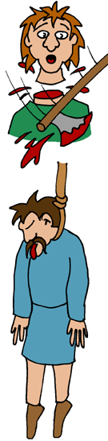As well as the rich grave mounds, there were two cemeteries for criminals at [Sutton Hoo](http://www.earlybritishkingdoms.com/kids/sutton_hoo.html).
* Simple graves were discovered around Mound 5 and in an area just to the east of the mounds.
* Like the famous [ship](http://www.earlybritishkingdoms.com/kids/sutton_ship.html), the bodies had rotted; but their outline could still be made out in the sand. They are sometimes called 'sand people':
  + Some had their heads or hands cut off.
  + Some had their hands together and feet together, as if they'd been tied up.
  + Some had dark marks in the soil round their necks, like a noose from a hanging.
* In the eastern cemetery, the remains of a gallows was found.
* Some of the bodies were from the same time as the mounds. Some were buried later.
* People who who did not follow the laws of the Kings of [East Anglia](http://www.earlybritishkingdoms.com/kids/eastanglia.html) were executed here. The Kings liked to show how powerful they were. A good place to do this was the place were their family was buried.
* In later times, the Christians may have thought the [pagan](http://www.earlybritishkingdoms.com/kids/pagan_saxons.html) cemetery was a good place to execute people who didn't follow Christian teachings.