Greek Baklava

Ingredients:

- 400g chopped nuts
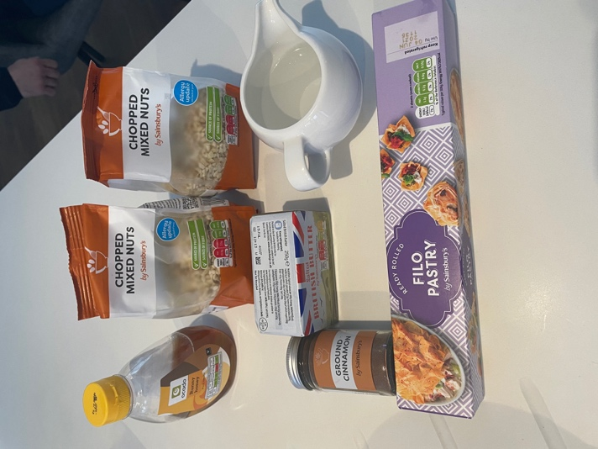
- 1 teaspoon ground cinnamon
- 2 packets filo pastry
- 250g butter melted
- 250ml water
- 125ml honey

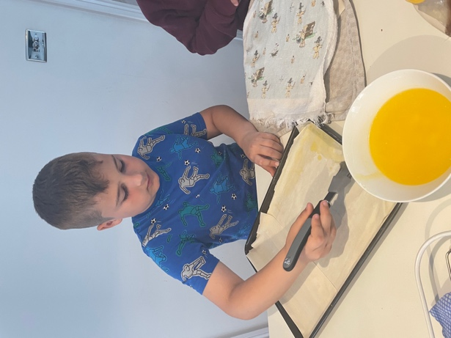
Grease the tray with butter
And then begin to layer filo
pastry sheets. Coat with butter.

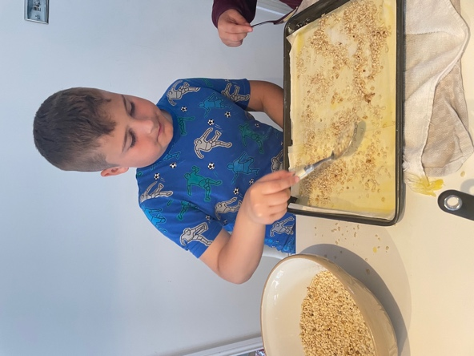

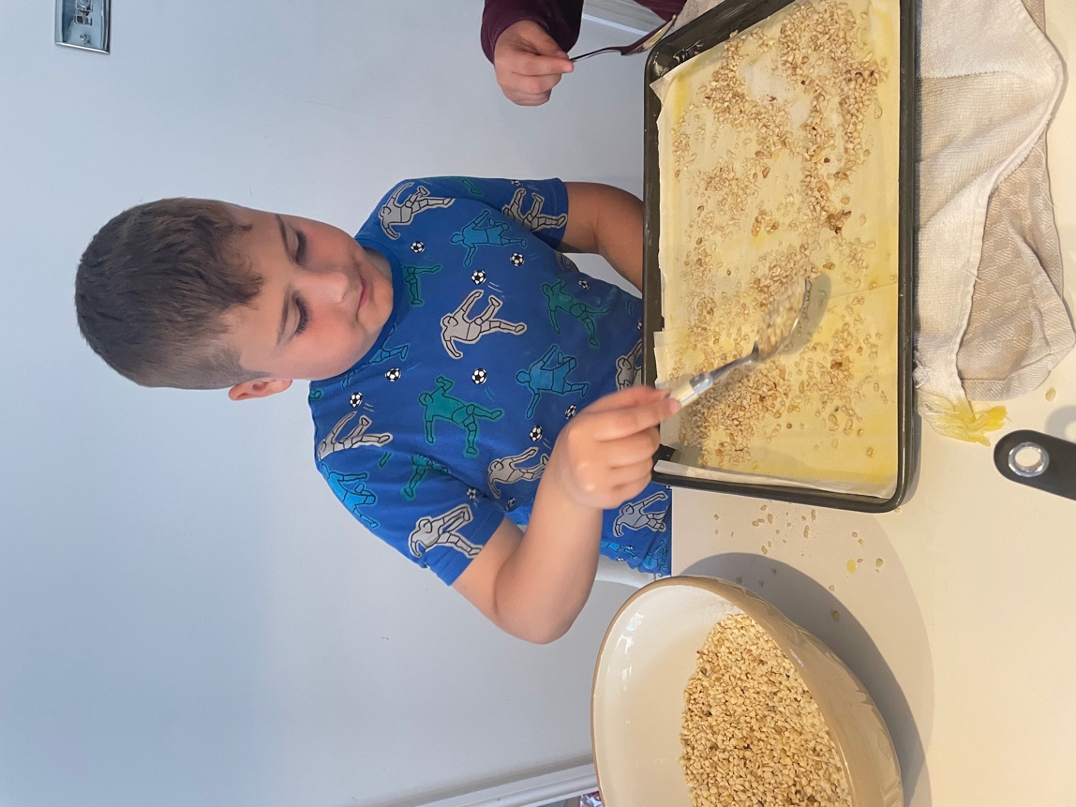
Sprinkle with nuts and repeat.

Cut into diamond shapes before
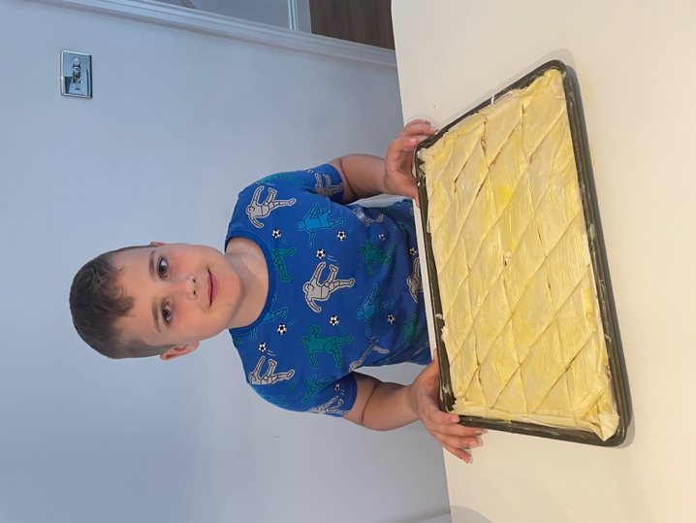
putting in oven for 25 minutes

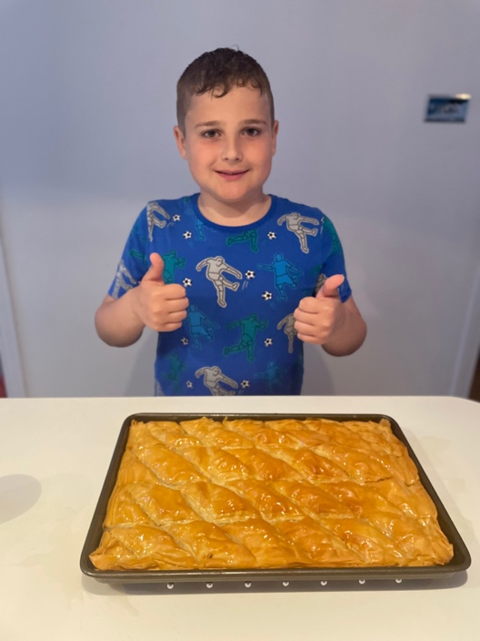

Pour over syrup made from sugar, water
And honey and allow to cool.

Now for the taste testing by my family!
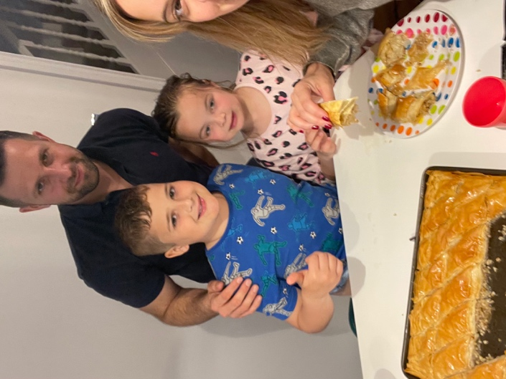
Mummy: “Wow, this is delicious!!”
Daddy: “What a fantastic dish you have
Created, much better than any shop bought
version I have tried.”
Imogen: Yummy! 10/10

