Weekly Work - Home Learning for Self Isolating Pupils
Class: Barn Owl and Kestrel | Week Beginning: 09.11.2020

Literacy | - Ask an adult to write out the sounds learnt so far on individual cards – (see below). Manipulate the cards to make a word that you know. If this proves too tricky, your adult can give a word – e.g sit, sat, tip, dog, pug.  - Continue to practise writing the sounds learnt so far – s, a, t, p, i, n, m, d, g, o, c, k, e, u. Focus on correct formation of letters. Practise writing your name with correct formation.  - Play phoneme frames, starting with VC (vowel-consonant words), and if able move onto CVC frames (consonant-vowel-consonant).  These look like this:  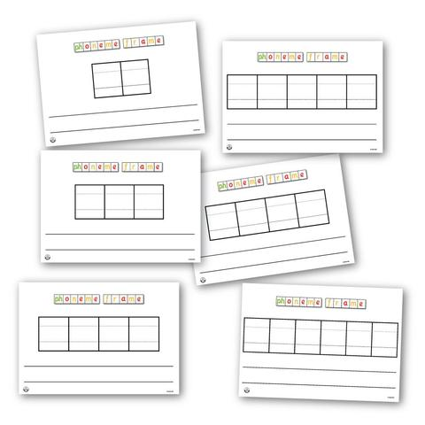 Write the letters you will be using above the frames. Say a word – e.g it, at, is, in, on or CVC - sat, sit, nap, top, tip  Your child should write each sound in each box, learning ‘first (initial), middle and end (final) sound.  - Read books (depending in what your child is fetching home) on Oxford Owl e-library https://www.oxfordowl.co.uk/for-school/oxford-owl-ebook-collection  Try to encourage your child to tell the story using the character names and he/she pronouns correctly and using ‘first, then, next’ words.  - This week we are starting our new theme of ‘Let’s Celebrate!’ We are holding a birthday for all the children in the class on Thursday. In preparation for this, we will write a card to someone in our class to invite them to the party. Can you use your sounds to write a birthday card to someone you love? Use the tricky word ‘to’ and have a go at hearing as many sounds as you can to write ‘Happy Birthday’. What sounds do you hear in ‘from’? Can you sign it with your name written as neatly as you can?
Phonics | This week we are recapping all sounds learnt so far – ck, e, u, r and learning the tricky words to, the, I, no, go, into  Use these links to follow the Reception phonics scheme at home (they are the same as last week so please practise the lessons and try at things you found hard last week):  - Monday – Lesson 16 https://www.youtube.com/watch?v=gY7448bXLJI https://www.youtube.com/watch?v=mdYVk_FuL90  - Tuesday – Lesson 17 https://www.youtube.com/watch?v=iF-2HlavdcM https://www.youtube.com/watch?v=b8MBR-4H-sA  - Wednesday – Lesson 18 https://www.youtube.com/watch?v=32QRcAD09K0 https://www.youtube.com/watch?v=bS4588dXbdg  - Thursday – Lesson 19 https://www.youtube.com/watch?v=DX9rNXLKoUI https://www.youtube.com/watch?v=XL2w1W2hGsI  - Friday - Lesson 20 https://www.youtube.com/watch?v=GLUM-vsf99Y https://www.youtube.com/watch?v=iJas_8PjSh0
Numeracy | - Keep practising to recognise numbers between 0- 20. Play arranging them in forwards or backwards directions.  - Practise getting the digits in the correct order for 10-20 (even when children appear confident in recognising them, it is much more difficult to correctly write them).  - Let your adult draw the basic 2d shapes on some paper (square, triangle, circle, rectangle, semi-circle - maybe even a pentagon and hexagon). Using child’s scissors, cut out the shapes, while describing the shapes using language such as ‘sides’, ‘corners’ to count how many. What’s the difference between a square and a rectangle? What’s similar about a circle and semi-circle?  - Go on a shape hunt around the house. Can you find any shapes in the environment? What shapes are your windows? Bricks? Steering wheel?
Understanding the World | Wednesday is Remembrance Day.  Use the following clip - BBC Children's remembrance film. A beautiful and evocative animation that sees war as experienced by animals in a WWI battlefield. https://www.bbc.co.uk/programmes/b04p4zsl  Or find on https://www.youtube.com/watch?v=pv_ub7Be7oA  Talk to your child about how poppies are a symbol worn in November to remember people who died.  How can you make a poppy? Maybe you would like to draw or paint a picture of the field as in the film, or maybe you could use paper and a straw to create a poppy?
Creative | At school this week we are doing the following creative activities:  - Making fairy cakes for our party – talking about how we celebrate birthdays (candles, music etc). Have your very own family party!  - Making poppies  - Making a cone shaped hat, first printed with 2D shapes  - Exploring colour-mixing by painting each hand a different colour then rubbing them together to discover the new colour.  - Cutting out a large shape from A3 sugar paper and using the technique of painting around the edge in lines to get a feel for how many sides. Continue to paint a new line inside that shape until you end up in the middle.  Choose any of the above activities to do depending on your resources.
RE | Link this week’s birthday theme to getting ready for Christmas. Christmas is Jesus’ birthday. He is so special to Christians all over the world that they spend a long time getting ready for Christmas. What things have you started to think about or do in preparation for Christmas? How can you celebrate it?
PE | Cosmic Kids Yoga – Sonic the Hedgehog  https://cosmickids.com/video/sonic-the-hedgehog/

Please remember there’s also lots of resources online including: Phonics Play (user name: march20, password: home) visit phase 1 and 2 areas.
If your Google Classroom is up and running, please upload to this. If not please email your work to the class email.

