**The Classic Paper Cup and String Phone**

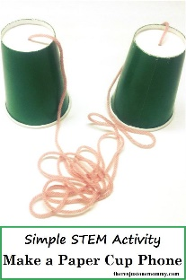Try making this telephone.

**Supplies Needed:**

* 2 paper cups
* Long string, like fishing line, kite string
* A sharp pencil or needle to poke holes in the cups
* Scissors

**What to Do:**

1. Start by cutting a long piece of string of at least 50 feet.

2. Poke a small hole at the bottom of each cup.

3. Using each end of the string, thread it through the bottoms of the cups, tying a large knot so that the string does not fall out of the cup. If you make the holes too large, use a washer or paper clip to hold the string in place so that it does not pull out of the cup.

4. Give a cup to one person and the second person move away from the first person so that the string is far enough to make it tight. Be sure that the string does not touch any other object and that it remains suspended in air as you complete the experiment.

5. Taking turns, talk into the cup, while the other person listens by putting the cup to their ear. Try to repeat what he or she hears after you have spoken and do the same in return!

Explain to an adult what you think is happening.

Sound waves created by talking through the cup travel through the line to the other end, converting back to sound on the opposite side!