Weekly Work - Home Learning for Self Isolating Pupils
Class: Penguin and Grey Seal | Week Beginning: 07.12.20

Literacy | 1) Complete this week’s guided reading questions. Make sure you refer to the text. See how many you can complete in one hour. Spelling and detail are important.  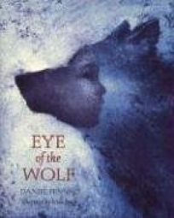  2) Think back to the chapter called ‘The Human Eye’ that we read from ‘The Eye of the Wolf’ last week. What is the author’s view on deforestation? Research some of the reasons for deforestation. List these on your page. Who is to blame for deforestation? Is it simply the fault of the people employed to cut down the trees or are consumers to blame? Write a paragraph to explain your thoughts. Brainstorm a list of five adjectives to explain how deforestation makes you feel. Create an acrostic poem for ‘deforestation’ using some of your ideas.  3) Just like Africa does, we are going to look deep into the eyes of an animal to see the world from their perspective. Look at Resource sheet 9a from the Literacy Resources section. What images do you think the Gorilla would show us (about how humans are destroying the planet) within its eyes, if it could. Discuss these with an adult if possible. Now look at Resources 9b - 9g, discussing the images and the impact these would have on you if seeing them swirl within the gorilla’s eyes. Imagine the gorilla showing each image dissolving into the next like a series of opposites (before and after). Look at the unfinished poem on Resource sheet 9h. Notice how the writer has used opposites to show the extremes of the gorilla’s life as seen through his eyes– he was free and now he is in captivity; he lived in dense jungle, then this was reduced to tree stumps etc. Explain that the part you are missing is the description of the opposite images we have just looked at. It is your task to write this section using precise, considered vocabulary choices.  4) Extra challenge: Think of one of the other animal characters mentioned in the book. Can you write your own poem entirely, inspired by the example you’ve been given?
Numeracy | Log into your MyMaths account and search for the following tasks: ‘Translating Shapes’ and ‘Midpoint and line length 1’. Complete these carefully. (It would be a good idea to work through the online lessons before you attempt the tasks.)  Complete the White Rose ‘Position and Direction’ end of block assessment from the Maths Resources section. (Answers are provided.)
Science | 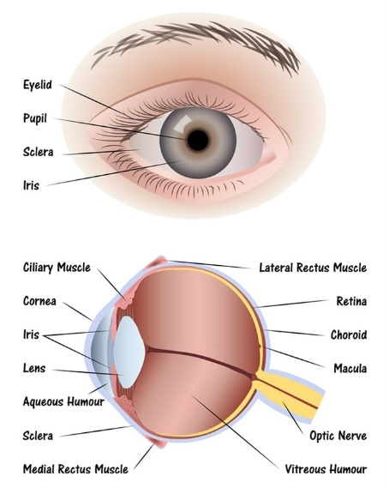  Research the human eye. Draw and label your own diagram showing the main parts. (The following parts should be included: lens, retina, iris, pupil, optic nerve, cornea, sclera and vitreous body.) Annotate your diagram to explain the function of each part. Write a short paragraph to explain how we see things and how the human eye is similar to a camera.
PE | Complete one of the following:  Cosmic Yoga  Go Noodle Dance  Joe Wicks workout on YouTube  You should spend between 20 and 30 minutes exercising each day.

Please remember there are also lots of resources online including: Oaks Academy, BBC Bite-size, Phonics Play. If your Google Classroom is up and running, please upload to this. If not please email your work to the class email.

