Weekly Work - Home Learning for Self Isolating Pupils
Class: Penguin and Grey Seal | Week Beginning: 16.11.20

Literacy | 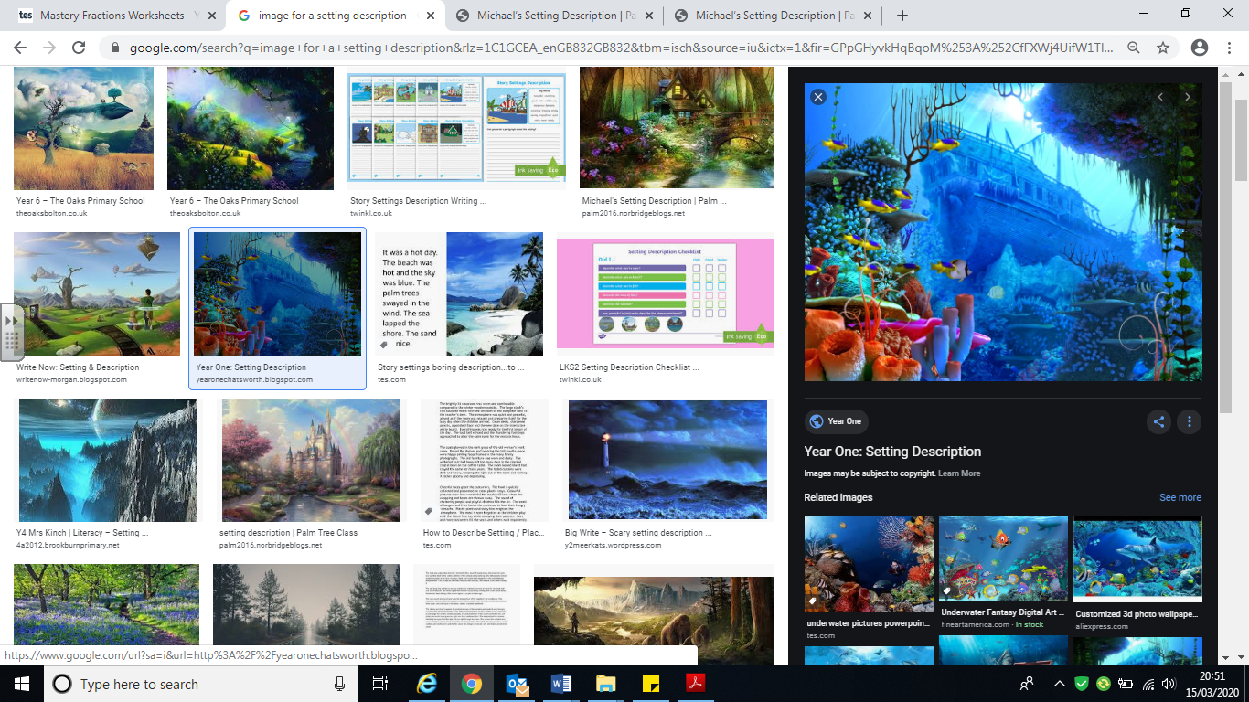  - Complete this week’s guided reading questions. Make sure you refer to the text. See how many you can complete in one hour. (We do not expect you to manage all of the questions.)  - Imagine you were out scuba diving when you came across the following scene.  Write a setting description for the image above. Try to include powerful adjectives, expanded noun phrases, similes and a variety of sentence openers. Think about as many of your senses as you can. Include prepositional phrases. What do you see just above, down below, beyond, almost out of view for example?  - Read the non-fiction article about Mexico which you will find in the literacy resources. Consider the information and then answer the comprehension questions that you are provided with. Use full sentences when you do this and make sure you repeat part of the question in your answer. ANSWERS ARE PROVIDED.
Numeracy | Complete the maths worksheets that can be found in the maths resources section. These are called: ‘Multiply fractions by integers’, ‘Multiply fractions by fractions’, ‘Divide fractions by integers (1)’ and ‘Divide fractions by integers (2)’. ANSWERS ARE PROVIDED.
Science | Our new science unit this half-term is ‘Light’. Your task is to devise an experiment to prove that light travels in straight lines. Please write a short description of what you did and ask an adult to take a photograph of you carrying out the experiment.
PE | Complete 20 - 30 minutes of exercise each day. You could use some of the old Joe Wicks sessions or devise your own programme of exercise. Make sure you build in some ‘warm up’ and ‘cool down’ activities as part of this.

Please remember there are also lots of resources online including: Oaks Academy, BBC Bite-size, Phonics Play. If your Google Classroom is up and running, please upload to this. If not please email your work to the class email.

