Week beginning 7th December 2020 Can I perform simple tests?
Aim | Can I investigate which materials are waterproof?
Prediction
Experiment – What we did. | ___________________________________________________________  ___________________________________________________________  ___________________________________________________________ |  |  |  |  | Which would be best for wrapping a present because it is waterproof and opaque.
Results | 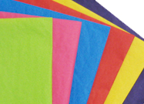 | 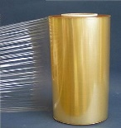 | 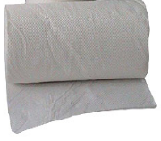 |   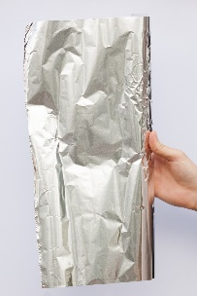 | 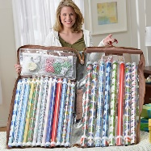

Conclusion

