Weekly Work - Home Learning for Self Isolating Pupils

|  |  |
| --- | --- |
| Class: Hedgehog and Fox | Week Beginning: Monday 7th December |

|  |  |
| --- | --- |
| Literacy | * Finish writing the Nativity story and draw some pictures to go with it. * Advent reading comprehension attached – read the information together and then discuss the questions. * Using the photo attached finish off the story about Rudolf. * Read a Christmas story together and write a book report – think about what you liked, who the characters were and why you might recommend to someone else to read. * Cut and stick the snowman to match the capital letter. You could even have a go at making some Christmas words. |
| Numeracy | * Play game on topmarks - <https://www.topmarks.co.uk/ordering-and-sequencing/christmas-patterns> * Using coins – find out how much money Ben might have in his purse using 5 coins. * Choose a colour by number picture (print it out if you can). * Play a maths game together – dominoes. Snakes and ladders etc. |
| Science | Investigate how a material is waterproof.  Using some different types of materials that can be used to wrap presents eg. Clingfilm, tin foil, wrapping paper, tissue.  Drop some water on them using a dropper. Does the water come through? Record what you find out.  Then using the materials that are waterproof think about whether they are also opaque. Make suggestion about what would be good to wrap a present.  waterproof what would make a good wrapping for a present opaque and waterproof. |
| Art | Find and make a Christmas card. |
| Geography | Using the powerpoint attached or doing your own research – find out about Christmas in Australia and create a fact sheet. |
| PE | Make a circuit of different activities you can do to keep moving, eg bounce on trampoline, jumping jacks, clap under knee, pass ball around body, Score a goal etc. |

Please remember there’s also lots of resources online including: Oaks Academy, BBC Bitesize, Phonics Play.

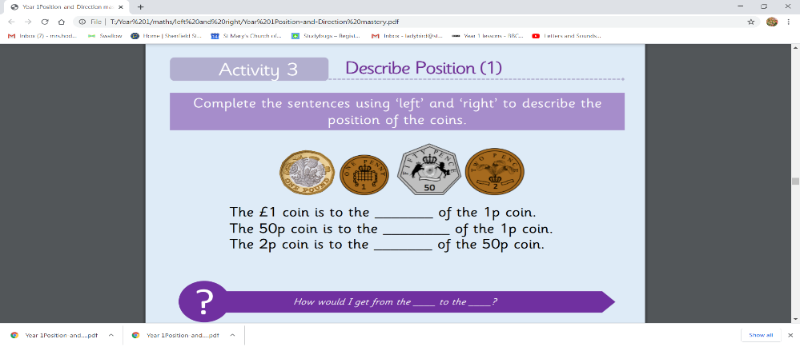If your Google Classroom is up and running, please upload to this. If not please email your work to the class email.