Weekly Work - Home Learning for Self Isolating Pupils

|  |  |
| --- | --- |
| Class: Hedgehog and Fox | Week Beginning: Tuesday 3rd November 2020 |

|  |  |
| --- | --- |
| Literacy | * Complete a simple sentence by ordering words activity. * Read together Powerpoint about joining sentences with and, complete task. * Write simple sentences using and to describe picture. * Reading comprehension read sentences and complete picture to match. |
| Numeracy | * Watch left and right song – <https://www.youtube.com/watch?v=LFsVrQ65JuE> * Practise vocabulary of left and right by giving and following simple instructions. * Play left and right game. * Talk through with an adult the right and left flash cards. * Using different coins describe their position to each other as in example below. |
| Science | Explore some of your different toys, think about the materials they are made from. How can you sort them? Is there more than 1 way? |
| Art | Create your own firework art work, think about the colours and you see. |
| History | Guy Fawkes – who was he? Why and how do we remember him? |
| PE | Make a circuit of different activities you can do to keep moving, eg bounce on trampoline, jumping jacks, clap under knee, pass ball around body, Score a goal etc. |

Please remember there’s also lots of resources online including: Oaks Academy, BBC Bitesize, Phonics Play.

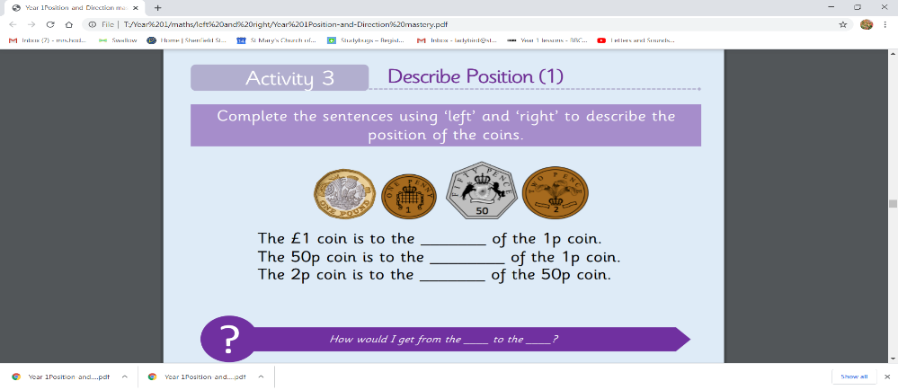If your Google Classroom is up and running, please upload to this. If not please email your work to the class email.